C
Chateau Walk
Homeowners
Association
Neighborhood News
October 2022

The Pool Closes Monday, October 10
The Annual Meeting of Chateau Walk HOA is Wednesday, November 9 at 7:00 pm Please join members of the board and your neighbors at our annual meeting held at the Smyrna Community Center, 200 Village Green Cir SE, Smyrna, GA 30080 at 7:00 pm on Wednesday, November 9. We will hold the meeting in the Dogwood room. We will serve light refreshments. We will elect one new board member at the annual meeting. If you are interested in serving on the board, please send your interest to Gary LaRue at gary.larue@gmail.com. Keitra Osborne, who served on the board for the last three years, has agreed to serve a second term if elected at the annual meeting.
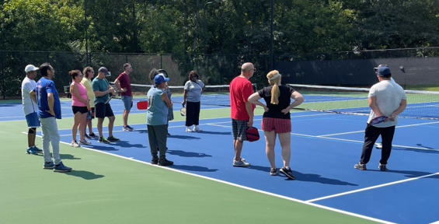
Grand Opening Party and Pickleball! We had a perfect day and an excellent turnout for the tennis court grand opening and pickleball introduction. Over thirty people took a swing at pickleball. Thanks to my constant support, Lesley LaRue, in handling the sign-in tent and being the best hostess! We gave away two pickleball racket sets to lucky homeowners!

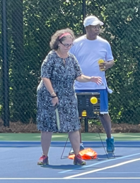
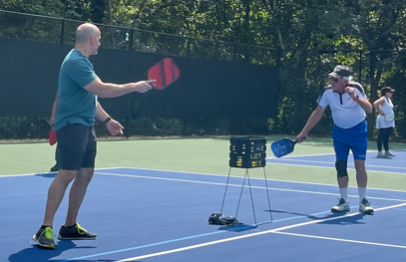

Tennis Courts Are Complete! Construction of the courts is complete. Landscaping is complete. Installation is complete with new security cameras. Please know we are SERIOUS about any vandalism or anyone that does not accept and agree to the tennis court rules. Violators will have amenities privileges revoked. That applies to both the pool and tennis court access.

Tennis Court Rules To restate the tennis court rules one more time:

- Proper attire is required. Tennis shoes only. Shoes that may mark or mar the court surface are prohibited.
- Courts are for Tennis/Pickleball/Basketball only; other activities or sports of any kind are prohibited, including but not limited to Baseball, Football, Soccer, and Hockey.
- All players are responsible for clean-up after play.
- No glass is allowed on the courts.
- No fireworks are allowed on the courts.
- Jumping over, pulling on, or sitting on the nets is prohibited.
- Climbing the tennis court fence is prohibited.
- Smoking, and illegal drug use, are prohibited.
- The tennis facility is for the use of the homeowners and renters of properties in Chateau Walk and Martha’s Vineyard.
- No more than four (4) guests. Guests must use the court being used by the homeowner or renter. Homeowners or renters must be with their guests at all times. The homeowner or renter is responsible for the actions of their guests.
- We do not allow bikes, roller blades, hoverboards, roller skates, skateboards, or other equipment in the tennis facility except for disabled support devices.
- We do not allow pets of any kind in the tennis facility.
- Play is first come, first served. (Walkup Play) Tennis/pickleball courts are open for use when there is no reservation. Tennis/pickleball are limited to one hour if others are waiting to use a court. Basketball is limited to 30 minutes if players wait to use the tennis/pickleball courts. We permit basketball play only when the tennis/pickleball courts are not in use or there are no players ready to use the courts.
- The reservation shall be honored if a reservation was made for a tennis/pickleball court. No exceptions. The reservation is revoked if a reservation does not show for the reserved time after 10 minutes.
- Make your reservations through www.ChateauWalk.com. Reserve My Court application.
- Play shall always be respectful and courteous. We do not tolerate rough play, foul language, taunting, or aggressive play.
- No music, loudspeakers, or radios are allowed in and around the tennis facilities.
- Entrance to the tennis facility is with the mag key issued to each home. Do not loan the mag key to others to enter the tennis facility. Do not permit anyone to enter the tennis facility without a mag key. Do not prop open the gate or do anything that allows uncontrolled entrance into the tennis facility.
- Violations of these rules will be the removal of your privileges to the tennis facility and pool.
- NO VANDALISM! NO DAMAGE TO THE FACILITY OR THE COURTS!

Thanks for being great neighbors,

Chateau Walk HOA Board
Merideth Hawks, Keitra Osborne, and Gary LaRue

